Acoustic and visual system to attract Caspian Tern (Hydroprogne caspia) to artificial islands in the Szczecin Lagoon, southern Baltic, Poland

Dominik Marchowski¹, Zbigniew Kajzer², Marcin Sołowiej², Sebastian Michałowski², Piotr Zientek², Michał Barcz², Paweł Stańczak², Michał Jasiński², Łukasz Jankowiak³
¹ Ornithological Station, Museum and Institute of Zoology, Polish Academy of Sciences, Gdańsk, Poland. ORCID: 0000-0001-7508-9466
Email: dmarchowski@miiz.waw.pl
² West Pomeranian Nature Society, Szczecin, Poland
³ Department of Ecology and Anthropology, Institute of Biology, University of Szczecin, Szczecin, Poland. ORCID: 0000-0002-3843-9778

Abstract
Restoration and conservation projects increasingly rely on artificial islands and other newly created habitats to support breeding colonies of rare or declining colonial waterbirds, as artificial islands can provide valuable substitutes for natural sandbanks and, under suitable conditions, attract breeding colonies. To attract Caspian Tern Hydroprogne caspia to nest, we designed, built, and field-tested a combined acoustic-visual attraction system on artificial island in the Szczecin Lagoon (north-western Poland) in 2025. The system was developed for long-term, maintenance-free operation under field conditions and powered by a photovoltaic panel with a gel battery. The acoustic module consisted of an autonomous audio playback unit broadcasting calls from active tern colonies via two weatherproof loudspeakers. The visual module included life-size 3D-printed decoys of Caspian Terns positioned within a manually cleared nesting patch of the area ~2,000 m². Bird activity and behaviour were monitored using motion-triggered camera traps operating throughout the breeding season, supplemented by periodic field checks. The system functioned reliably over several months under variable weather conditions, enabling detailed behavioural monitoring of the target species. Following deployment of the attraction system, a single Caspian Tern pair established a nest within the attraction area. Continuous camera monitoring allowed us to determine the exact timing of egg laying, incubation period, hatching dates, and chick development until fledging. This was the first documented successful breeding attempt of the Caspian Tern in Poland. To our knowledge, this study provides the first detailed, field-tested description of an integrated acoustic–decoy attraction system for Caspian Terns in Central Europe. The presented design provides a low-cost, replicable technical framework for restoration and conservation projects aimed at re-establishing breeding colonies of rare or declining colonial waterbirds on newly created or restored coastal habitats.

Keywords: social facilitation, habitat restoration, colony establishment, monitoring technology, camera traps, breeding success, coastal conservation
Introduction
In the altered environment of regulated river valleys devoid of natural sandbanks, and with anthropogenic pressure on sandy sea beaches, natural breeding habitats for waterbirds are lacking (Marchowski et al. 2024). Birds nesting in pioneer habitats include gulls, terns, and waders (Charadriiformes). Human-altered environments, such as gravel pits and artificial islands created during large hydrotechnical projects (Sługocki et al. 2025), are increasingly substituting natural sandbanks or coastal beaches (van der Winden et al. 2024). In some large projects, artificial habitats are created for the mentioned groups of birds as environmental compensations (Marchowski et al. 2023). However, birds are not always able to find them immediately. Thus in such cases, social attraction can be used to encourage birds to inhabit these habitats (Hartman et al. 2019, Herrera-Giraldo et al. 2021, Pynenburg et al. 2017, Ward et al. 2011).
Attraction techniques, including the use of decoys and sound playback, form part of a broader framework of sensory-based conservation that exploits species-specific communication and signalling behaviours to restore or establish breeding colonies of seabirds (Friesen et al. 2017). Their effectiveness has been demonstrated in a range of empirical studies, particularly for terns and gulls, using visual and acoustic cues to attract birds to restored or newly created habitats (Hartman et al. 2019, Herrera-Giraldo et al. 2021, Kotliar & Burger 1984, Kress 1983, Parker et al. 2007, Pynenburg et al. 2017). However, in Central and Eastern Europe, documented applications of these methods remain scarce, and empirical studies focusing especially on large tern species, such as the Sandwich Tern Thalasseus sandvicensis, are still rare (Bzoma et al. 2023).
Caspian Tern Hydroprogne caspia – the largest tern species globally – is widely distributed across all continents except Antarctica and typically breeds colonially on sparsely vegetated coastal or inland islands and sandbanks, where breeding success is strongly influenced by disturbance and habitat instability (Cuthbert & Wires 2020). In Poland, the species has been regularly recorded as migrants but breeding has been never documented until 2024, when a pair nested on one of the newly created artificial islands in the Szczecin Lagoon (Stańczak et al. 2024). This first breeding attempt failed during the chick stage, prompting the implementation of active attraction measures at the same location in 2025 to encourage recolonization.
To encourage the return of Caspian Terns and to evaluate the effectiveness of social attraction methods under local conditions, we implemented a restoration programme on the same island in 2025. The project involved: (1) the installation of an autonomous playback system broadcasting calls recorded at active colonies, accompanied by a set of 3D-printed Caspian Tern decoys; (2) continuous monitoring of bird activity within the prepared area using motion-triggered camera traps; (3) detailed documentation of tern and gull breeding activity on two islands in the Szczecin Lagoon using a combination of camera traps, standard observer-based surveys, and individual identification of chicks through ringing with metal and plastic colour rings, subsequently read using optical equipment.
In this study, we specifically aimed to: (1) describe the social attraction system design for Caspian Terns; (2) determine whether Caspian Terns responded to the attraction cues and initiated nesting within the prepared attraction area; and (3) evaluate the usefulness of camera traps as a tool for documenting the effectiveness of the attraction system as well as the breeding performance of Caspian Terns.
Study area and experimental context
Two artificial islands W22 (53.791711°N, 14.450848°E) and W28 (53.749055°N, 14.499349°E) were created between 2019 and 2022 in the Szczecin Lagoon (north-western Poland). The islands were built by the Maritime Office in Szczecin using dredged material from the shipping channel (Sługocki et al. 2025).
Our main study was conducted on W28. Outer outline of this island was created in June 2021. W28 is intended as a place for the ongoing deposition of dredged material from routine waterway maintenance in the lagoon, so in the following years the inner area of ​​the island changed – more land areas were created. A total area of the island in 2025 was 2.52 km², in that 2.12 km² of water surface and 0.4 km² of land (Marchowski et al. 2025). In addition to the main study site (W28), limited supplementary observations were also conducted on the smaller island W22, where no active attraction measures were implemented.
Soon after its formation W28 was colonised by Black-headed Gulls Chroicocephalus ridibundus and Common Terns Sterna hirundo, which provided suitable social cues for subsequent colonisation by other colonial waterbirds. In 2025 the breeding population of Black-headed Gull reached 7,500 pairs, Common Tern – 980 pairs, Little Tern Sternula albifrons – 24 pairs, the Mediterranean Gull Ichthyaetus melanocephalus – 7 pairs and Caspian Gull Larus cachinnans – 4 pairs (Marchowski et al. 2025).
In 2024, the first Caspian Tern breeding attempt was recorded on the island (Stańczak et al. 2024). The pair nested near the gull and tern colony, but the chicks disappeared under unknown circumstances shortly after hatching (Marchowski et al. 2024).

Attraction system design, construction and deployment
To attract Caspian Terns back to the site in 2025, we developed and deployed a combined acoustic and visual attraction system designed for long-term autonomous operation under field conditions. The system consisted of two key components: (i) an autonomous acoustic playback module operating in a continuous loop with a solar-powered energy supply comprising a photovoltaic panel, charge controller and rechargeable battery, and (ii) a visual attraction component based on life-size 3D-printed decoys.
Sound system design
The acoustic playback module was based on a TASCAM DR-100 MKII Linear PCM recorder (TEAC Corporation, Japan) configured for continuous loop playback. The main audio file consisted of a 42.24-minute recording of an active Caspian Tern breeding colony from Rice Island, located at the mouth of the Columbia River, North America (file size: 59,643 KB in MP3 format), supplemented by four shorter recordings of Caspian Tern colony calls from additional locations and two recordings from Sandwich Tern breeding colonies. Playback operated continuously (24 h day⁻¹) throughout the study period. Sound output was set to approximately 100 dB SPL (sound pressure level) at 1 m.
There is no evidence in the literature of geographically structured variation in Caspian Tern vocalizations; the species’ vocal repertoire is described as uniform across its breeding range (Cuthbert & Wires 2020). This is consistent with the monotypic status of the species, which lacks recognized subspecies and exhibits only minor, non-diagnostic geographic variation. Consequently, we used high-quality recordings from North America that have previously been applied successfully in Caspian Tern attraction projects, including those conducted in San Francisco Bay (Hartman et al. 2019).
Audio signals were broadcast via two weatherproof loudspeakers (4 Ω, 50 W each) connected to an external amplifier housed within the enclosure. Power was supplied by a 70 W photovoltaic panel connected to a 12 V / 20 Ah sealed gel battery via a solar charge controller, ensuring stable power delivery under variable weather conditions. To prevent overheating during periods of high solar radiation, the enclosure was equipped with an internal cooling fan controlled by a temperature sensor (Fig. 1).
All electronic components were mounted within a weatherproof IP65 rigid plastic enclosure (dust-tight and protected against water jets), with only the speaker fronts and the cable to the solar panel exposed (Fig. 1). The system was installed approximately 0.5 m above ground level and positioned about 20 m from the previous year’s Caspian Tern nest. Prior to field deployment, the complete system underwent a one-month outdoor test (28 March-15 April 2025) in a garden setting, allowing frequent inspection and adjustment (see Appendix 1, Fig. A1). Following successful testing, the system was transported to the study site and installed on the island on 16 April 2025.

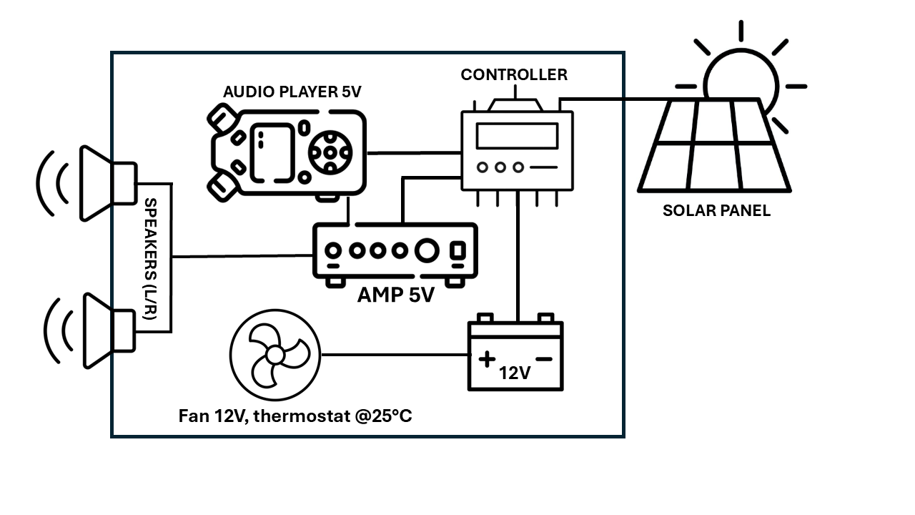
Fig. 1. Schematic diagram of the autonomous solar-powered audio playback system used for bird attraction experiments. AMP – amplifier.

Visual attraction module
The visual attraction component consisted of three life-size Caspian Tern decoys produced using 3D printing with UV-resistant ASA (acrylonitrile styrene acrylate) filament based on a digital model derived from a life-size sculpture by an artist. Each decoy was hand-painted with UV-stable acrylic paints to reproduce natural plumage tones and placed in incubating postures. Decoys were positioned at inter-nest distances of approximately 2 m, reflecting spacing typical of low-density Caspian Tern colonies (Antolos et al. 2006, 2004) (Fig. 2 and 3).

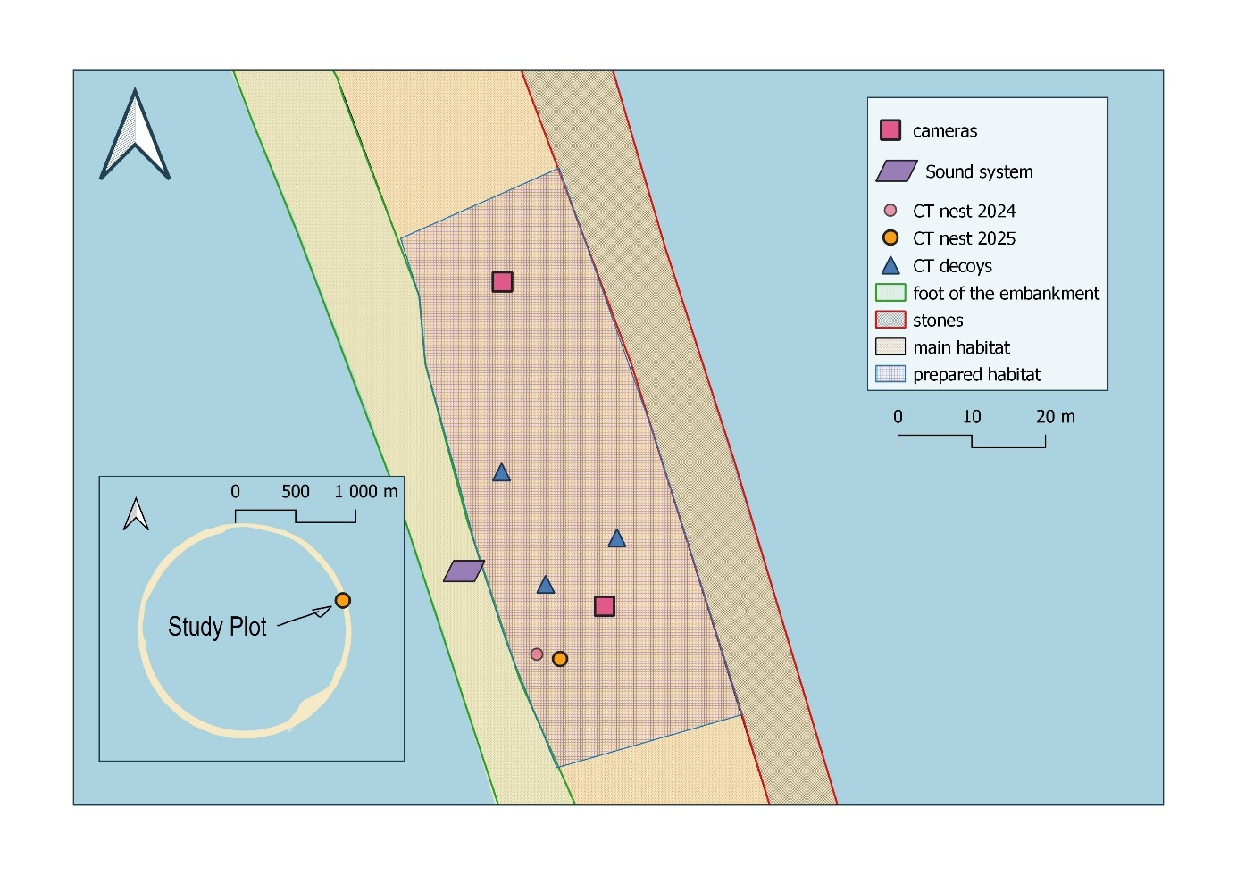
Fig. 2. Spatial layout of the acoustic-visual attraction system and tern nesting sites on Island W28 in 2025. The map shows the location of the autonomous sound system, 3D-printed decoys of Caspian Tern (CT, Hydroprogne caspia), and camera traps used for monitoring. The positions of Caspian Tern nests from 2024 (unsuccessful) and 2025 (successful) are indicated. Habitat zones include the main nesting area, stony margin, and the foot of the embankment. The inset map shows the position of the attraction setup within the island.
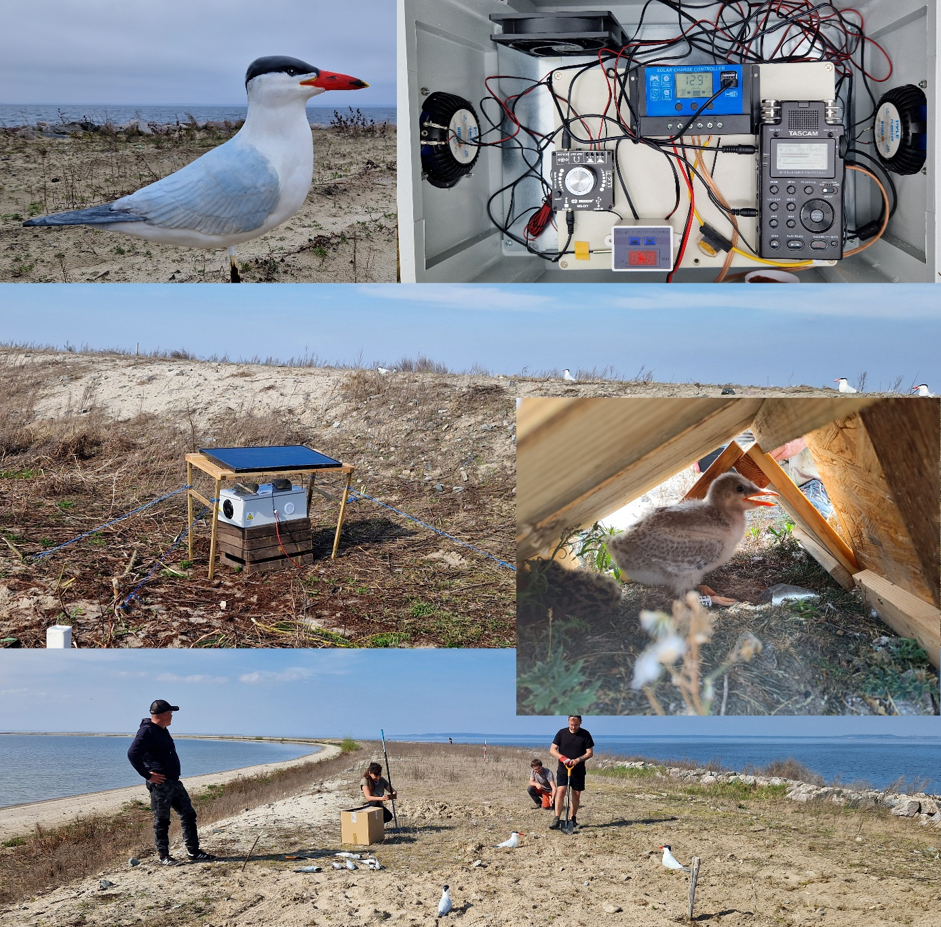
Fig. 3. Components and field deployment of the acoustic-visual attraction system for Caspian Terns Hydroprogne caspia on artificial island W28 in the Szczecin Lagoon. Top left: life-size 3D-printed Caspian Tern decoy positioned at the breeding site. Top right: interior of the weatherproof enclosure showing the autonomous sound playback system with power supply and control components. Centre: acoustic playback unit installed in the field and powered by a solar panel, with Caspian Tern decoys arranged along the crest of the island embankment. Inset (centre right): youngest Caspian Tern chick sheltered beneath a wooden cover at the nest site (26 June 2025). Bottom: volunteers preparing the nesting substrate and positioning decoys within the designated attraction area. Photo: Dominik Marchowski and Paweł Stańczak.

Site preparation: habitat clearance and chick shelters
Approximately 2,000 m² of surface area was manually cleared from vegetation (Fig. 2), creating an open sandy patch similar to preferred breeding substrates (Cuthbert & Wires 2020). Additionally, nesting shelters constructed of wood were installed in the area to provide protection from wind, rain and sun, as well as from predators (e.g. White-tailed Eagle Haliaeetus albicilla) for nestlings (Jenks-Jay 1982, Stoyan & Nachtigall 2021), (Fig. 3). The island is located at a considerable distance from the coast, with the nearest mainland approximately 2.8 km away. Consequently, access by terrestrial mammalian predators is limited. To date, no major predators, such as the American mink Neovison vison, raccoon Procyon lotor, or red fox Vulpes vulpes, have been recorded on the island. The installation was completed on 16 April 2025, before the arrival of terns in the region.

Monitoring and field procedures
Field surveys
Field surveys were conducted as standardised site visits aimed at documenting bird presence, breeding activity, and general habitat conditions on the artificial islands. Each visit involved a systematic walk covering the entire island perimeter and interior, with regular stops at fixed and opportunistic vantage points. During these stops, birds were scanned using optical equipment (binoculars and spotting scopes) to record species identity, numbers, behaviour, and breeding status, with particular attention paid to Caspian Terns and other colonial waterbirds (Marchowski et al. 2023).
Field visits were carried out on the following dates in 2025: 16 April, 6 May, 20 May, 2 June, 12 June, 26 June, 14 July, 9 August, 6 September, 7 October, 16 November, and 4 December. Observations obtained during field surveys complemented data collected using camera traps and were used to verify breeding status, chick development, and post-breeding and migratory presence. Post-breeding visits (September–December) were oriented mainly towards testing and evaluating the long-term performance of the attraction system, which remained installed at the site throughout this period, including power supply, battery charging efficiency, and overall system durability under field conditions.

Camera traps configuration and operation
Bird activity at the attraction site on island W28 was monitored using two motion-triggered camera traps (Browning BTC-8E-HP5, Browning Trail Cameras, USA) configured to record short video clips. Camera trap #1 was positioned near the previous year’s Caspian Tern nest and the decoy-playback system to capture close-range behavioural interactions, whereas camera trap #2 was placed approximately 50 m away from the nest to provide a broader spatial context of bird activity within the attraction area (Fig. 2).
Both camera traps operated continuously, day and night, and were equipped with infrared illumination for nocturnal recording. Each camera was powered by eight AA batteries and equipped with SD memory cards with capacities ranging from 32 to 128 GB. Video recording was triggered by motion detection, with the nominal video length set to 5 s, video quality set to “Ultra”, a photo delay of 10 min between consecutive triggers. In practice, individual video clips occasionally exceeded the nominal recording duration, likely due to internal camera processing and trigger behaviour. These two camera traps constituted the primary data source for the analysis of bird behaviour and breeding activity associated with the attraction system.
On the second island (W22), eight additional camera traps were deployed in photo mode with motion-triggered, with a standard two-shot multishot mode, activation and identical power and memory configurations. These cameras were randomly distributed across the island and used exclusively as a supplementary monitoring tool to detect the presence of breeding terns, other waterbirds, and potential predators. Data from camera traps on W22 were not included in the quantitative analyses and served only to complement observer-based field surveys. Batteries and memory cards were replaced during field visits (see above for the dates).

Results of system operation
Performance of the attraction system
On 16 April, the system was transported to its final deployment site, island W28, where it continuously operated (24 h/day, 7 days/week) between 17 April and the second part of July. The minimum confirmed duration of continuous operation was from April 16, 2025, at 4:00 PM to July 14, 2025, at approximately 11:00 AM – a total of 88 days and 19 hours, or 2,131 hours of uninterrupted functioning.
During a field visit on 9 August, it was found that the system had stopped functioning because the solar panel was covered with bird droppings, preventing charging. After the panel was cleaned, the system resumed normal operation. Battery charge and system performance were further tested on-site at W28 on 6 September, 7 October 2025, 16 November 2025 and 4 December. In all cases the battery voltage exceeded 12.5 V, indicating a nearly full charge. The system remained in place throughout the entire study period and was not dismantled. However, after the end of breeding season (August – December) the acoustic playback was temporarily switched off. The power supply and battery charging system remained active to allow continuous testing of charging efficiency under field conditions. On selected days, the playback was reactivated to verify system performance, and in all cases the system operated correctly.
Caspian Tern occurrence and breeding behaviour
On May 6th, at W28, a pair of adult birds was observed on a prepared surface area, and a hole in the ground – the future nest – was identified, devoid of eggs. Three eggs were laid, and all hatched successfully after ~ 25 days of incubation. Three young birds were ringed with steel rings and plastic rings with an alphanumeric code. The oldest chick had become volant at 14.07.2025 at the age of 42 days (the plastic ring was read on a flying bird), while the youngest, at that time, was observed to be almost able to fly. The fate of the middle chick remains unknown, and it likely did not survive. Detailed observations of the nest are presented in the Appendix 1, Table A1. No Caspian Tern breeding attempts were observed on island W22, but a few sightings of adult birds during the breeding season have been recorded (Table A1). Links to selected episodes recorded from camera traps can be found in Appendix 1.
Camera trap operation at the W28 site
The cameras operated from April 16, 2025, to June 13, 2025, for a total of 43 days, including camera #1 for 17 days and camera #2 for 26 days. The average number of footages per day was 306, the highest intensity of footage was in camera #1 in the period 20-23 May – the incubation period. (Table 2, Fig. A2). Due to low battery voltage or memory card fullness, the camera #1 was inactive for 26 days and the camera #2 for 17 days during the studied period (Fig A2 in Appendix 1). Links to the video repository with selected episodes can be found in Appendix 1
Table 1. Summary of camera trap operation periods. DO – Days of operation; NOF – Number of footages; File size – total video file size (GB). Stage – of the breeding season: PRL – pre-laying, INC – incubation, CHR – chick-rearing
Date | Stage | DO | NOF | File size (GB) | NOF/DAY | CAMERA ID
16-20.04.2025 | PRL | 5 | 407 | 29.8 | 81 | #2
16-21.04.2025 | PRL | 6 | 689 | 29.4 | 115 | #1
06-08.05.2025 | PRL | 3 | 1,371 | 59.3 | 457 | #2
06-09.05.2025 | PRL | 4 | 1,784 | 59.9 | 446 | #1
20.05-02.06.2025 | INC | 18 | 4,260 | 77.3 | 237 | #2
20-23.05.2025 | CHR | 3 | 2,981 | 84.4 | 994 | #1
02-03.06.2025 | CHR | 2 | 1,007 | 59.3 | 504 | #1
12-13.06.2025 | CHR | 2 | 655 | 28.5 | 328 | #1
TOTAL | All stages combined | 43 | 13,154 | 427.9 | 306 | #1 & #2 combined

Discussion
Attraction system performance
The attraction system developed in this study proved technically reliable and well suited for long-term autonomous operation under field conditions. Continuous sound playback was maintained for at least 2,131 hours, representing a conservative estimate, as the precise shutdown time prior to 9 August could not be determined. Importantly, subsequent inspections between September and December showed a nearly fully charged battery despite prolonged periods of cloudy and rainy weather, indicating that the 70 W photovoltaic panel provided sufficient energy to sustain uninterrupted operation throughout the breeding season and beyond.
These results demonstrate that the system is robust, scalable and may be readily applied in other outdoor settings requiring long-term autonomous acoustic deployment. Although used here to attract breeding birds, similar configurations could be adapted for deterrence purposes, such as reducing bird presence at buildings, airports, or other sensitive sites (Coughlan et al. 2022, Swaddle et al. 2016).
Assessing the biological effectiveness of acoustic-visual attraction systems remains challenging, as the spatial range and behavioural impact of such stimuli are difficult to quantify and vary widely among species and ecological contexts. Acoustic playback is generally assumed to operate over larger spatial scales than visual decoys, particularly in open coastal or wetland habitats where sound can be detected by prospecting individuals from considerable distances (Friesen et al. 2017). In contrast, decoys are primarily short-range visual cues that may facilitate final site assessment once birds approach a potential breeding location (Kotliar & Burger 1984, Kress 1983).
Evidence from studies on terns and other colonial waterbirds indicates that the effectiveness of social attraction techniques is highly context-dependent. While several experiments have shown increased site visitation and, in some cases, initiation of nesting in response to decoys and playback (Bzoma et al. 2023, Kotliar & Burger 1984, Kress 1983), other studies have found limited or no effects when these methods were applied in isolation, with habitat quality, predator pressure, and interspecific competition exerting stronger influences on colony establishment (Pynenburg et al. 2017). Reviews of sensory-based conservation consistently conclude that attraction systems are most effective when combined with favourable site conditions and mitigation of limiting factors, rather than acting as primary drivers of colonisation (Friesen et al. 2017, Herrera-Giraldo et al. 2021).
Taken together, these findings suggest that acoustic-visual attraction systems should be viewed as facilitative tools that may increase site detectability and perceived suitability but rarely override broader ecological constraints. In this context, the reliable technical performance of the system described here represents a necessary, but not sufficient, condition for breeding establishment, and its potential contribution must be interpreted alongside habitat characteristics, disturbance regimes, and the availability of experienced or prospecting individuals.
Caspian Tern occurrence and breeding behaviour
It is difficult to assess whether the attraction system directly influenced the establishment of a breeding attempt in 2025, as it cannot be determined whether Caspian Terns would have occupied the site in the absence of the system. The breeding attempt recorded in 2024 at the same location ended unsuccessfully, with chicks disappearing shortly after hatching, most likely due to predation by White-tailed Eagles, which represent a major threat to Caspian Tern colonies in the Baltic region (Cuthbert & Wires 2020, Stańczak et al. 2024). According to the widely documented “win-stay, lose-switch” principle, unsuccessful breeding often leads birds to abandon a site in subsequent seasons (Bai & Severinghaus 2012, Bialas et al. 2023, Mariné & Cadiou 2019). In this context, renewed breeding activity in 2025 would not necessarily be expected without additional facilitating factors.
The nest recorded in 2025 was located only 1.5 m from the nest site used in 2024, which could suggest site fidelity by the same pair or at least one returning individual. However, this interpretation remains speculative, as adult birds were not ringed. Available literature indicates that Caspian Terns exhibit variable nest-site fidelity that depends strongly on habitat stability and prior breeding success. Studies from large colonies have shown that individuals often return to previous nesting areas when suitable habitat persists but may shift nest locations or abandon sites following habitat loss or repeated breeding failure (Collar 2013). Thus, both local philopatry and site switching are plausible explanations for the observed nesting pattern.
An alternative explanation is that the attraction system facilitated site discovery or reassessment by different individuals. The Szczecin Lagoon and the surrounding Odra estuary constitute an important migratory stopover for Caspian Terns during both spring and autumn movements between Baltic breeding grounds and African wintering areas (Rueda-Uribe et al. 2021). During late summer migration, up to 150 individuals from the Baltic population have been recorded roosting on newly created islands in the region (Stańczak et al. 2024). Repeated use of these sites by migrating birds may enhance spatial memory and increase the likelihood that they are later perceived as suitable breeding habitat.
It is also important to note that natural succession is progressing rapidly on both artificial islands. Areas initially characterised by open sand and gravel have become increasingly overgrown by willow, reeds, and herbaceous vegetation (Marchowski et al. 2024). Active removal of vegetation and maintenance of open substrate during the study period likely contributed to habitat suitability for Caspian Terns, independently of the attraction system. Camera trap footage documented individuals landing within the cleared area and visually inspecting decoys while colony vocalisations were audible in the background, suggesting that multiple cues may have acted jointly in site assessment.
Finally, the placement of wooden shelters near the nest was repeatedly observed to be used by chicks, likely providing protection from weather and potential predators. Although the contribution of these shelters to breeding success cannot be quantified, similar structures have been shown to enhance chick survival and increase effective nest density in other tern species (Babcock & Booth 2020, Stoyan & Nachtigall 2021).
Overall, the breeding event observed in 2025 most plausibly reflects the combined influence of habitat preparation, reduced disturbance, and the presence of social cues, rather than the effect of the attraction system alone. While the system may have facilitated site detection or reassessment, broader ecological context and habitat suitability remain critical determinants of breeding occurrence in Caspian Terns.
The usefulness of a camera traps
The use of motion-triggered camera traps provided detailed, continuous documentation of Caspian Tern breeding behaviour that would have been difficult to obtain using standard observer-based methods alone. Camera traps allowed precise determination of key breeding stages, including incubation onset, hatching sequence, chick survival, and fledging, while minimising direct human disturbance at the nesting site.
Camera traps are increasingly used in studies of colonial waterbirds and seabirds, particularly to monitor breeding phenology, predator activity, and behavioural responses to environmental conditions or management interventions (Caravaggi et al. 2017). In the present study, their application was especially valuable given the novelty of the breeding site, the sensitivity of Caspian Terns to disturbance, and the need for continuous monitoring of a single breeding pair.
The results demonstrate both the strengths and limitations of camera trapping in dense or semi-colonial breeding contexts. Although the cameras generated a very large volume of data (0.43 TB of video material), battery depletion and memory card saturation resulted in temporal gaps, with approximately 50% of days lacking continuous recordings. Such limitations are well recognised in camera trap studies employing video mode, particularly when recording is triggered frequently by movement in active colonies (Bak et al. 2025, Fennell et al. 2022). Nevertheless, despite these gaps, the cameras provided sufficient temporal resolution to reconstruct the full breeding chronology and assess chick survival until fledging.
Importantly, camera traps also enabled the documentation of rare or otherwise unobservable behaviours, such as nest inspection by prospecting birds, chick use of wooden shelters, and interactions with neighbouring breeding species. Similar applications of camera traps have proven effective in assessing the outcomes of seabird restoration and attraction projects, including evaluations of predator presence, breeding success, and responses to social attraction devices (Herrera-Giraldo et al. 2021).
Overall, while camera traps should not be viewed as a replacement for traditional field surveys, their integration with observer-based monitoring represents a powerful methodological approach for studying breeding ecology in sensitive or newly established seabird colonies. Their use is particularly justified in technical or methodological studies aimed at evaluating restoration tools, where continuous, low-disturbance observation is essential.
Conclusions and recommendations
This study presents a field-tested example of an integrated acoustic-visual attraction system applied to Caspian Terns on newly created artificial islands in the Szczecin Lagoon. Although it is not possible to determine conclusively whether the system directly caused the breeding attempt recorded in 2025, the results indicate that such systems may function as facilitative tools that enhance site detectability and attractiveness under favourable ecological conditions. Importantly, the system proved technically robust, enabling long-term autonomous operation under variable weather conditions and demonstrating suitability for deployment in remote environments.
Breeding parameters observed during the 2025 season, including incubation duration and the period from hatching to fledging, were consistent with published data from other Caspian Tern colonies (Cuthbert & Wires 2020), suggesting that breeding proceeded within normal biological limits. Combined with habitat preparation and continuous monitoring, the attraction system allowed detailed documentation of breeding chronology at a site where Caspian Terns had previously attempted to breed unsuccessfully.
At the same time, our findings align with earlier studies indicating that the effectiveness of social attraction techniques is highly context-dependent and often difficult to disentangle from broader ecological drivers. Experimental work has shown that decoys and playback can increase site visitation and sometimes initiate nesting, particularly at suitable or historically occupied sites (Kotliar & Burger 1984, Kress 1983). However, subsequent studies demonstrate that social attractants alone rarely determine colony establishment, with habitat quality, predator pressure, and disturbance regimes often playing a more decisive role (Friesen et al. 2017, Herrera-Giraldo et al. 2021, Pynenburg et al. 2017). Consequently, attraction systems should be viewed as supportive rather than determinative tools, whose apparent success likely reflects interactions with environmental conditions and the availability of experienced or prospecting individuals.
From a practical perspective, several considerations emerge for future applications. Acoustic and visual attractants should be deployed only where suitable nesting habitat is present or can be created and maintained. Continuous video monitoring using camera traps proved valuable but generated large data volumes and led to temporal gaps due to battery depletion or memory saturation, indicating that improved power supply solutions – such as integrating camera traps with external solar panels – could substantially enhance monitoring efficiency and data continuity. The role of playback later in the breeding season also warrants careful consideration, while useful for attracting prospecting individuals early in the season, breeding adults appeared to habituate rapidly and largely ignore both playback and decoys once nesting commenced. However, continued playback may still facilitate the arrival of late breeders or individuals that have failed at other sites, and therefore we recommend maintaining the attraction system throughout the entire breeding season rather than terminating playback immediately after initial site occupancy.
The use of playback recordings from non-local colonies is considered appropriate in this case. Caspian Terns are largely monotypic, and no geographic variation in vocalisations has been documented in the literature (Cuthbert & Wires 2020). Differences in acoustic environments among colonies are therefore more likely driven by associated species rather than by intraspecific variation in Caspian Tern calls.
In conclusion, although this study does not demonstrate a direct causal effect of social attraction on colony establishment, it provides a detailed technical and methodological framework for the application of attraction systems in seabird conservation. When integrated with habitat management and appropriate monitoring, such systems may contribute meaningfully to restoration efforts for Caspian Terns and other colonial waterbirds.

Acknowledgements
We thank the Maritime Office in Szczecin for their cooperation and logistic support.
We thank Dr. C. Alex Hartman (U.S. Geological Survey, Western Ecological Research Center, Dixon, California) for kindly providing original audio recordings of Caspian Tern colonies, which were used in developing the acoustic component of our attraction system. We are grateful to Dr. Simon Piro (University of Greifswald, Germany) for providing the 3D model used to print tern decoys employed in the attraction experiments.
The project was co-financed by the Ministry of Science under the "Regional Excellence Initiative" Program for 2024-2027 (RID/SP/0045/2024/01).
Fieldwork and system testing were part of the statutory work of the Ornithological Station, Museum and Institute of Zoology, PAS.
We are grateful to all collaborators involved in island management and monitoring in 2025: Justyna Ciemińska, Maciej Gierszewski, Andreas Graversen, Frank Joistein, Wiktor Kilinowski, Michał Kizielewicz, Adam Loręcki, Amare Gibru Mekonnen, Urszula Mordacz, Kinga Piórkowska, Maciej Przybysz, Sławomir Rubacha, Daniela Stencyk, Dariusz Wysocki

References
Antolos M., D.D. Roby, K. Collis 2004 – Breeding Ecology of Caspian Tern at Colonies on the Columbia Plateau – Northwest Science, 78: 303–312.
Antolos M., D.D. Roby, D.E. Lyons, S.K. Anderson, K. Collis 2006 – Effects of Nest Density, Location, and Timing on Breeding Success of Caspian Terns – cowa, 29: 465–472. https://doi.org/10.1675/1524-4695(2006)29%255B465:EONDLA%255D2.0.CO;2
Babcock M., V. Booth 2020 – Chick Shelters. Tern Conservation Best Practice (No. LIFE14 NAT/UK/000394) – . RSPB & BirdWatchIreland, London.
Bai M.-L., L.L. Severinghaus 2012 – Disentangling site and mate fidelity in a monogamous population under strong nest site competition – Animal Behaviour, 84: 251–259. https://doi.org/10.1016/j.anbehav.2012.05.004
Bak T., R.J. Camp, M.D. Burt, S. Vogt 2025 – Automated methods for processing camera trap video data for distance sampling – Pacific Conserv. Biol., 31. https://doi.org/10.1071/PC25008
Bialas J.T., J. Siekiera, A. Siekiera, W. Chromik, Ł. Dylewski, M. Tobolka 2023 – Age, brood fate, and territory quality affect nest-site fidelity in white stork Ciconia ciconia – Frontiers in Zoology, 20: 33. https://doi.org/10.1186/s12983-023-00506-y
Bzoma S., A. Janczyszyn, A. Kośmicki, H. Trzeciak 2023 – Sprawozdanie z usługi pn. Monitoringi poinwestycyjne zadania „Modernizacja układu falochronów osłonowych w Porcie Północnym w Gdańsku” – Monitoring ornitologiczny w sezonie lęgowym 2023 – . Waterbird Research Group KULING, Gdańsk.
Caravaggi A., P.B. Banks, A.C. Burton, C.M.V. Finlay, P.M. Haswell, M.W. Hayward, M.J. Rowcliffe, M.D. Wood 2017 – A review of camera trapping for conservation behaviour research – Remote Sensing in Ecology and Conservation, 3: 109–122. https://doi.org/10.1002/rse2.48
Collar S. 2013 – Site fidelity and colony dynamics of Caspian terns nesting at East Sand Island, Columbia River Estuary, Oregon, USA (Graduate Theses and Dissertations (GTD)) – . Oregon State University, Oregon.
Coughlan N.E., W. O’Shea, R.N. Cuthbert, T.C. Kelly, N. Mitham, J. Nicholson 2022 – The fox in the box: acoustic deterrent and simulated predator disturbance to reduce problematic bird accumulations – wilr, 50: 237–247. https://doi.org/10.1071/WR22032
Cuthbert F.J., L.R. Wires 2020 – Caspian Tern (Hydroprogne caspia), version 1.0 – Birds of the World. https://doi.org/10.2173/bow.caster1.01
Fennell M., C. Beirne, A.C. Burton 2022 – Use of object detection in camera trap image identification: Assessing a method to rapidly and accurately classify human and animal detections for research and application in recreation ecology – Global Ecology and Conservation, 35: e02104. https://doi.org/10.1016/j.gecco.2022.e02104
Friesen M.R., J.R. Beggs, A.C. Gaskett 2017 – Sensory-based conservation of seabirds: a review of management strategies and animal behaviours that facilitate success – Biological Reviews, 92: 1769–1784. https://doi.org/10.1111/brv.12308
Hartman C.A., J.T. Ackerman, M.P. Herzog, C. Strong, D. Trachtenbarg 2019 – Social attraction used to establish Caspian tern nesting colonies in San Francisco Bay – Global Ecology and Conservation, 20: e00757. https://doi.org/10.1016/j.gecco.2019.e00757
Herrera-Giraldo J.-L., C.E. Figuerola-Hernández, C.A. Wolf, R. Colón-Merced, E. Ventosa-Febles, S. Silander, N.D. Holmes 2021 – The use of social attraction techniques to restore seabird colonies on Desecheo Island, Puerto Rico – Ecological Solutions and Evidence, 2: e12058. https://doi.org/10.1002/2688-8319.12058
Jenks-Jay N. 1982 – Chick Shelters Decrease Avian Predation in Least Tern Colonies on Nantucket Island, Massachusetts – Journal of Field Ornithology, 53: 58–60.
Kotliar N.B., J. Burger 1984 – The Use of Decoys to Attract Least Terns (Sterna antillarum) to Abandoned Colony Sites in New Jersey – Colonial Waterbirds, 7: 134–138. https://doi.org/10.2307/1521092
Kress S.W. 1983 – The Use of Decoys, Sound Recordings, and Gull Control for Re-Establishing a Tern Colony in Maine – Colonial Waterbirds, 6: 185–196. https://doi.org/10.2307/1520987
Marchowski D., Z. Kajzer, Ł. Jankowiak, M. Sołowiej, S. Michałowski, P. Zientek, M. Barcz, P. Stańczak, M. Jasiński 2025 – Ptaki lęgowe wysp na Zalewie Szczecińskim w latach 2021-2025 – raport. Dynamika liczebności i zalecenia ochronne., 1st ed – . Research & Conservation Team – Brysna, Szczecin.
Marchowski D., Z. Kajzer, S. Michałowski, P. Stańczak, Ł. Jankowiak 2024 – New habitats for birds: rapid population growth and new breeding species in Poland – Oryx, 58: 694–695. https://doi.org/10.1017/S0030605324001169
Marchowski D., Z. Kajzer, M. Sołowiej, S. Michałowski, M. Barcz, M. Jasiński, M. Kowalewski, A. Malecha, M. Przybysz, T. Rek, M. Sidelnik, P. Stańczak, Ł. Jankowiak 2023 – Pierwsza w Polsce kolonia lęgowa szablodziobów Recurvirostra avosetta na sztucznych wyspach Zalewu Szczecińskiego – Ornis Polonica, 273–287.
Mariné M., B. Cadiou 2019 – Breeding success, nest site fidelity and mate fidelity in the European Storm-petrel Hydrobates pelagicus – Seabird, 32: 46–58.
Parker M.W., S.W. Kress, R.T. Golightly, H.R. Carter, E.B. Parsons, S.E. Schubel, J.A. Boyce, G.J. McChesney, S.M. Wisely 2007 – Assessment of Social Attraction Techniques Used to Restore a Common Murre Colony in Central California – cowa, 30: 17–28. https://doi.org/10.1675/1524-4695(2007)030%255B0017:AOSATU%255D2.0.CO;2
Pynenburg B.P., D.J. Moore, J.S. Quinn 2017 – Efficacy of decoys and familiar versus unfamiliar playback calls in attracting Common Terns to a rehabilitated wetland on Lake Ontario – Aquatic Ecosystem Health & Management, 20: 285–294. https://doi.org/10.1080/14634988.2017.1311742
Rueda-Uribe C., U. Lötberg, M. Ericsson, S.V.M. Tesson, S. Åkesson 2021 – First tracking of declining Caspian terns Hydroprogne caspia breeding in the Baltic Sea reveals high migratory dispersion and disjunct annual ranges as obstacles to effective conservation – Journal of Avian Biology, 52. https://doi.org/10.1111/jav.02743
Sługocki Ł., U. Mordacz, Ł. Jankowiak, S. Michałowski, R. Czerniawski, D. Marchowski 2025 – Artificial islands supporting migratory bird populations as potential sources of microinvertebrate dispersal – Ecohydrology & Hydrobiology, 100660. https://doi.org/10.1016/j.ecohyd.2025.100660
Stańczak P., M. Barcz, Ł. Jankowiak, Z. Kajzer, M. Przybysz, M. Sobieraj, M. Sołowiej, P. Zientek, D. Marchowski 2024 – Pierwsze stwierdzenie lęgu rybitwy wielkodziobejHydroprogne caspia w Polsce – Ornis Polonica, 253–271.
Stoyan D., W. Nachtigall 2021 – The effect of artificial chick shelters on nest placement by Common Terns Sterna hirundo – Bird Study, 68: 345–350. https://doi.org/10.1080/00063657.2022.2050351
Swaddle J.P., D.L. Moseley, M.K. Hinders, E. P. Smith 2016 – A sonic net excludes birds from an airfield: implications for reducing bird strike and crop losses – Ecological Applications, 26: 339–345. https://doi.org/10.1890/15-0829
van der Winden J., C. Dreef, R. Posthoorn, Y.I. Verkuil 2024 – Human-Made 1,000 Hectare Archipelago “Marker Wadden” Has Positive Impact on Regional and Flyway Populations of Waterbirds of Dynamic Freshwater Ecosystems – cowa, 46: 185–195. https://doi.org/10.1675/063.046.0409
Ward M.P., B. Semel, C. Jablonski, C. Deutsch, V. Giammaria, S.B. Miller, B.M. McGuire 2011 – Consequences of using Conspecific Attraction in Avian Conservation: A Case Study of Endangered Colonial Waterbirds – cowa, 34: 476–480. https://doi.org/10.1675/063.034.0410

Appendix 1
Breeding chronology of the Caspian Tern
Table A1. Breeding chronology of the Caspian Tern Hydroprogne caspia on islands W22 and W28 in 2025, based on field observations and camera trap recordings.
Codes: U – individual observed, probably non-breeder; M – individual observed but suspected to be still on migration; P – pair in suitable habitat; i – individual; ad – adult; H – individual observed in the breeding season in suitable nesting habitat; ON – occupied nest (nest scrape without eggs); CO – copulation; NE – nest containing eggs; NY – nest or young in the area; IN – incubating eggs; FL – recently fledged young; A – agitated behaviour, e.g. chasing away another individual of the same species from the vicinity of the nest. Observation method: O – field observation; C – camera trap. Notes: All numerical values preceding behaviour categories indicate the number of individuals observed, unless stated otherwise. For incubation (IN), the duration given in days refers to the total length of the incubation period.
Date | Behaviour category / type |  | Observation method
 | W22 | W28
06.05.2025 | 4i H/M | ON, 1P, 5H/M | O
06.05.2025 | - | CO, 1P | C
08.05-02.06.2025 | - | IN (25-day, inc. period) + 1P | C
20.05.2025 | 3i U/M | NE (3 egs)+1P; 3U/M | O
22.05.2025 | - | IN, 1P, A | C
02.06.2025 | - | NE (3 egs, 1 hatching) + 1P | O
02.06.2025 | - | NY (1-st chick hatched) + 1P | C
03.06.2025 | - | NY (2-nd chicks hatched) + 1P | C
12.06.2025 | - | NY (3 chicks¹) + 1P | O
26.06.2025 | 1i U/H | NY (2 chicks²) +1P | O
14.07.2025 | 7ad. U | NY, FL (2 chicks³) + 1P | O
¹ the oldest chick is about 10 days old
² the oldest and the youngest, the oldest chick was about 24 days old
³ the oldest was already fledged (age – 42 days), and the youngest nearly so

Sound system performance
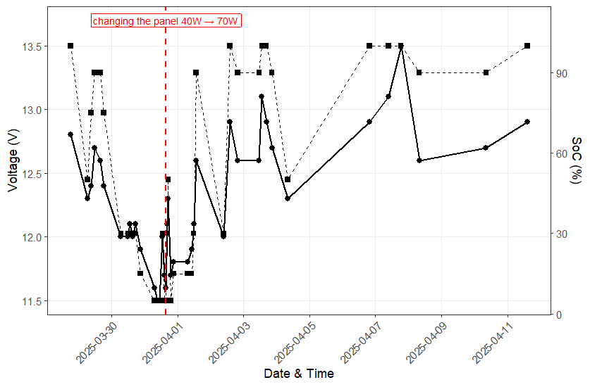
Fig. A1. Monitoring of voltage (V) and battery charge level (State of Charge, SoC %) in the attraction system between 28 March and 11 April 2025.
The solid line shows changes in battery voltage, while the dashed line represents the corresponding State of Charge (SoC %) values derived from the battery controller.
The red dashed vertical line indicates the moment when the photovoltaic panel was replaced (31 March 2025, 15:30), increasing its power from 40 W to 70 W.

Camera traps performance
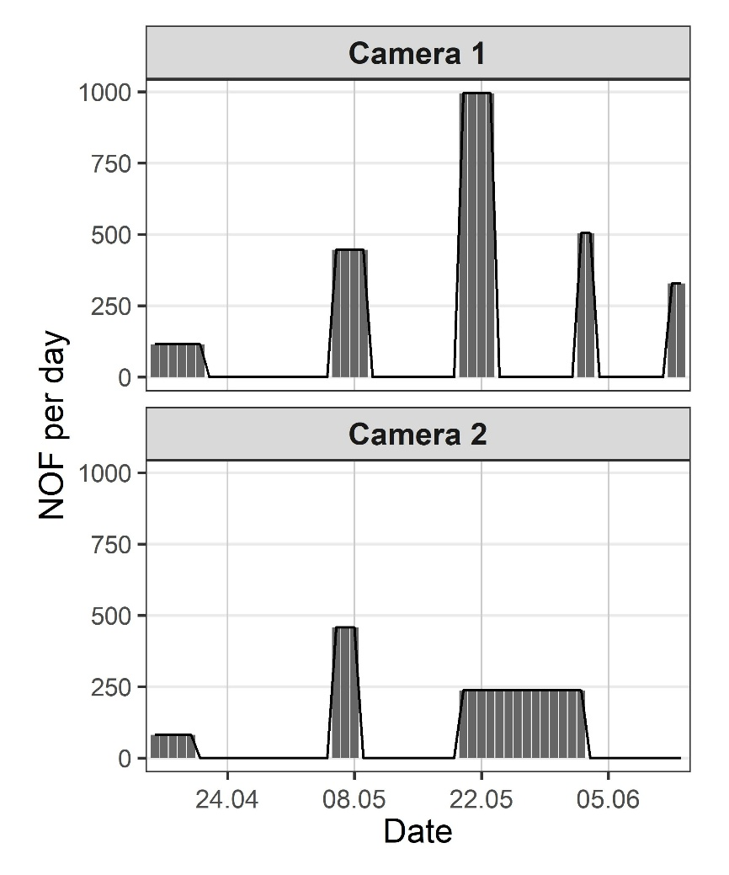
Fig. A2. Daily recording activity (NOF – number of footages per day) of two camera traps deployed between 16 April and 13 June 2025. Bars represent the mean number of video recordings per day during each operational period, while zero values indicate days when cameras were inactive due to full memory cards or depleted batteries. Camera #1 and Camera #2 operated intermittently, with distinct recording periods clearly visible in the time series.

Video repository links
Field operation of an integrated acoustic–visual attraction system for Caspian Terns
https://youtube.com/shorts/6saICFo54_s
Sample footages documenting significant episodes from the Caspian Tern breeding can be found in the YouTube video repository:
https://www.youtube.com/@dominikmarchowski/playlists

